**Creating Measures**

In this demo, you create measures to be included in your model. Like the calculated columns you created, a measure is a calculation created by using a DAX formula. However, unlike calculated columns, measures are evaluated based on a user selected filter. For example, a column or slicer added to the Row Labels field in a PivotTable. A value for each cell in the filter is then calculated by the applied measure. Measures are powerful, flexible calculations that you want to include in almost all tabular models to perform dynamic calculations on numerical data.

## **Create measures**

#### To create a DaysCurrentQuarterToDate measure in the DimDate table

1. In the model designer, click the **DimDate** table.
2. In the measure grid, click the top-left empty cell.
3. In the formula bar, type the following formula:

DaysCurrentQuarterToDate:=COUNTROWS( DATESQTD( 'DimDate'[Date]))

Notice the top-left cell now contains a measure name, **DaysCurrentQuarterToDate**, followed by the result, **92**. The result is not relevant at this point because no user filter has been applied.

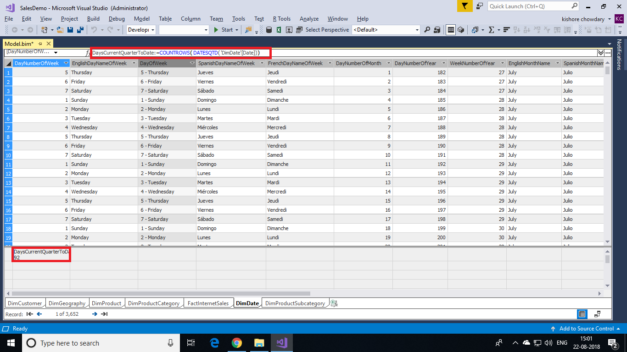

Unlike calculated columns, with measure formulas you can type the measure name, followed by a colon, followed by the formula expression.

#### **To create a DaysInCurrentQuarter measure in the DimDate table**

1. With the **DimDate** table still active in the model designer, in the measure grid, click the empty cell below the measure you created.
2. In the formula bar, type the following formula:

DaysInCurrentQuarter:=COUNTROWS( DATESBETWEEN( 'DimDate'[Date], STARTOFQUARTER( LASTDATE('DimDate'[Date])), ENDOFQUARTER('DimDate'[Date])))

When creating a comparison ratio between one incomplete period and the previous period. The formula must calculate the proportion of the period that has elapsed and compare it to the same proportion in the previous period. In this case, [DaysCurrentQuarterToDate]/[DaysInCurrentQuarter] gives the proportion elapsed in the current period.

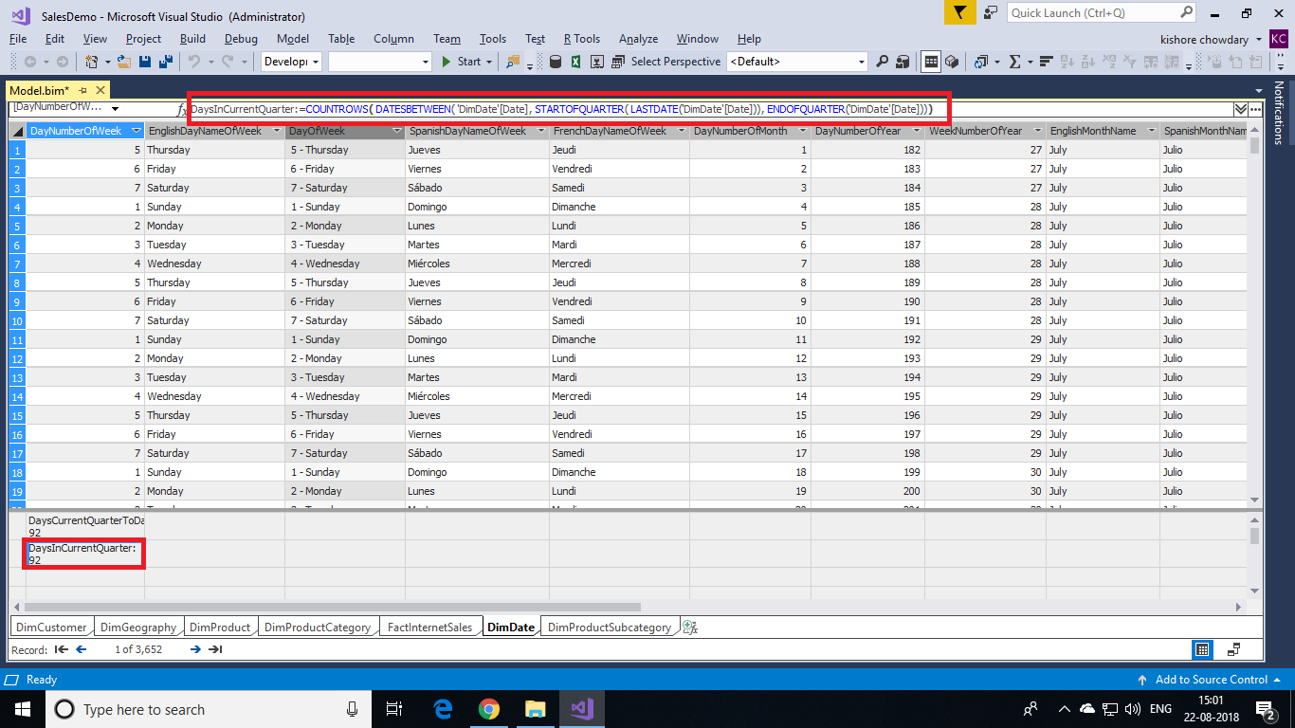

#### **To create an InternetDistinctCountSalesOrder measure in the FactInternetSales table**

1. Click the **FactInternetSales** table.
2. Click the **SalesOrderNumber** column heading.
3. On the toolbar, click the down-arrow next to the AutoSum (**∑**) button, and then select **DistinctCount**.

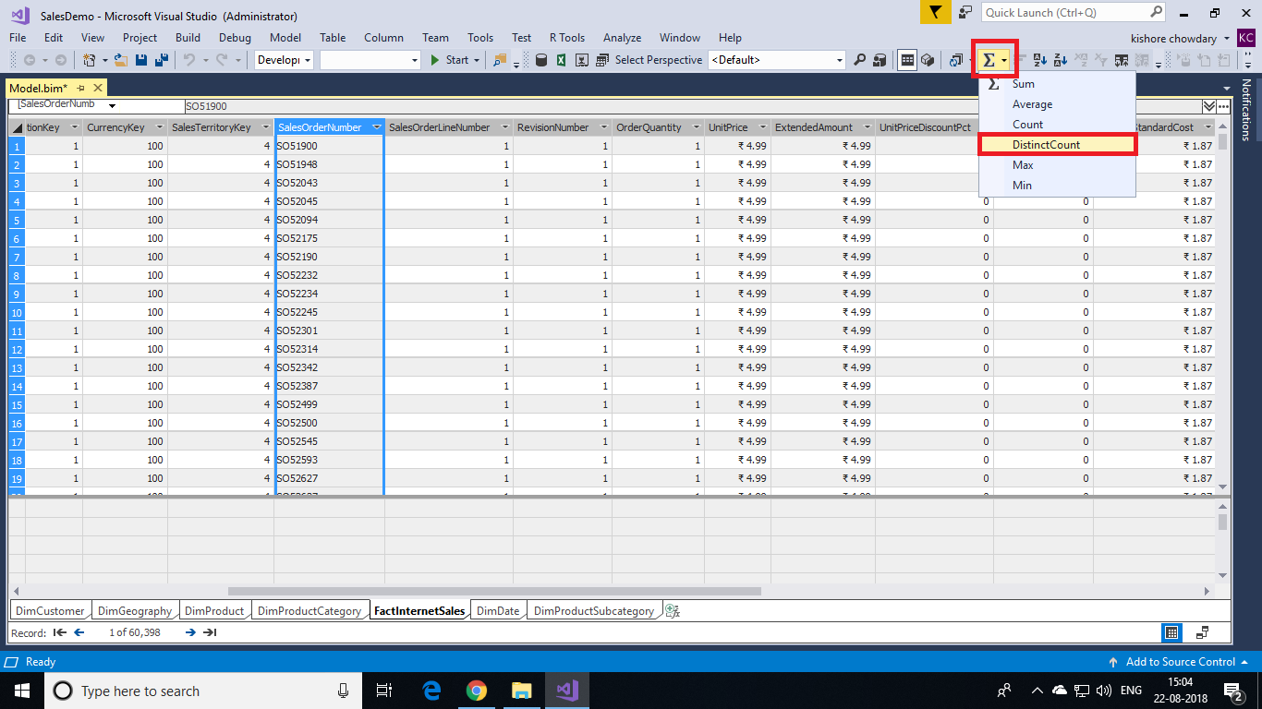

The AutoSum feature automatically creates a measure for the selected column using the DistinctCount standard aggregation formula.

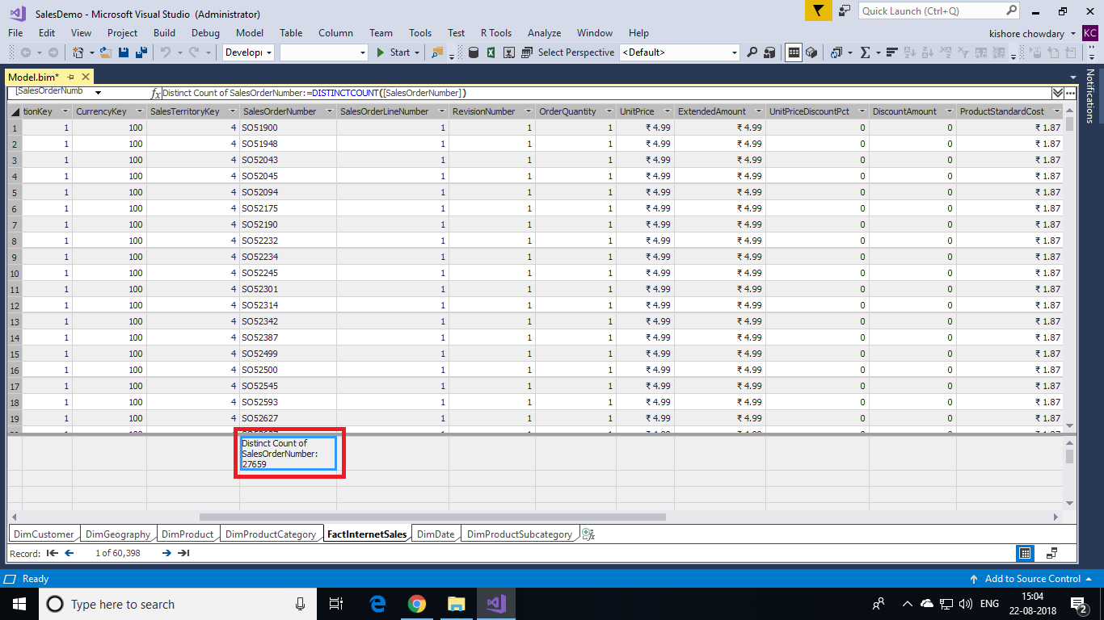

In the measure grid, click the new measure, and then in the **Properties** window, in **Measure Name**, rename the measure to **InternetDistinctCountSalesOrder**.

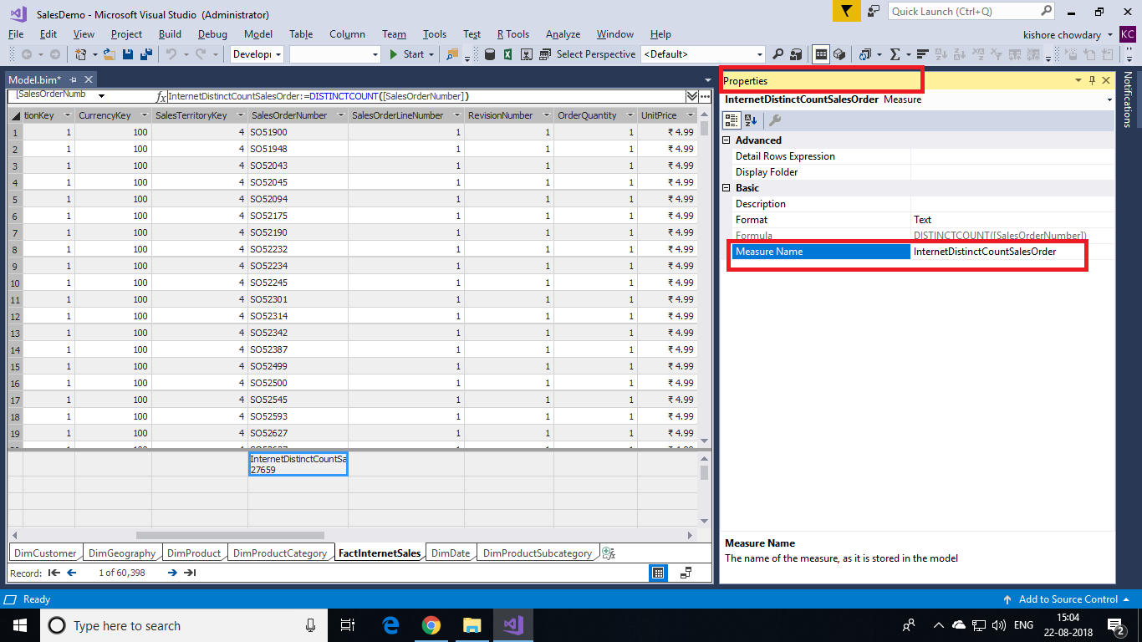

#### **Create additional measures in the FactInternetSales table**

1. By using the AutoSum feature, create and name the following measures:

|  |  |  |  |
| --- | --- | --- | --- |
| **Column** | **Measure name** | **AutoSum (∑)** | **Formula** |
| SalesOrderLineNumber | InternetOrderLinesCount | Count | =COUNTA([SalesOrderLineNumber]) |
| OrderQuantity | InternetTotalUnits | Sum | =SUM([OrderQuantity]) |
| DiscountAmount | InternetTotalDiscountAmount | Sum | =SUM([DiscountAmount]) |
| TotalProductCost | InternetTotalProductCost | Sum | =SUM([TotalProductCost]) |
| SalesAmount | InternetTotalSales | Sum | =SUM([SalesAmount]) |
| Margin | InternetTotalMargin | Sum | =SUM([Margin]) |
| TaxAmt | InternetTotalTaxAmt | Sum | =SUM([TaxAmt]) |
| Freight | InternetTotalFreight | Sum | =SUM([Freight]) |

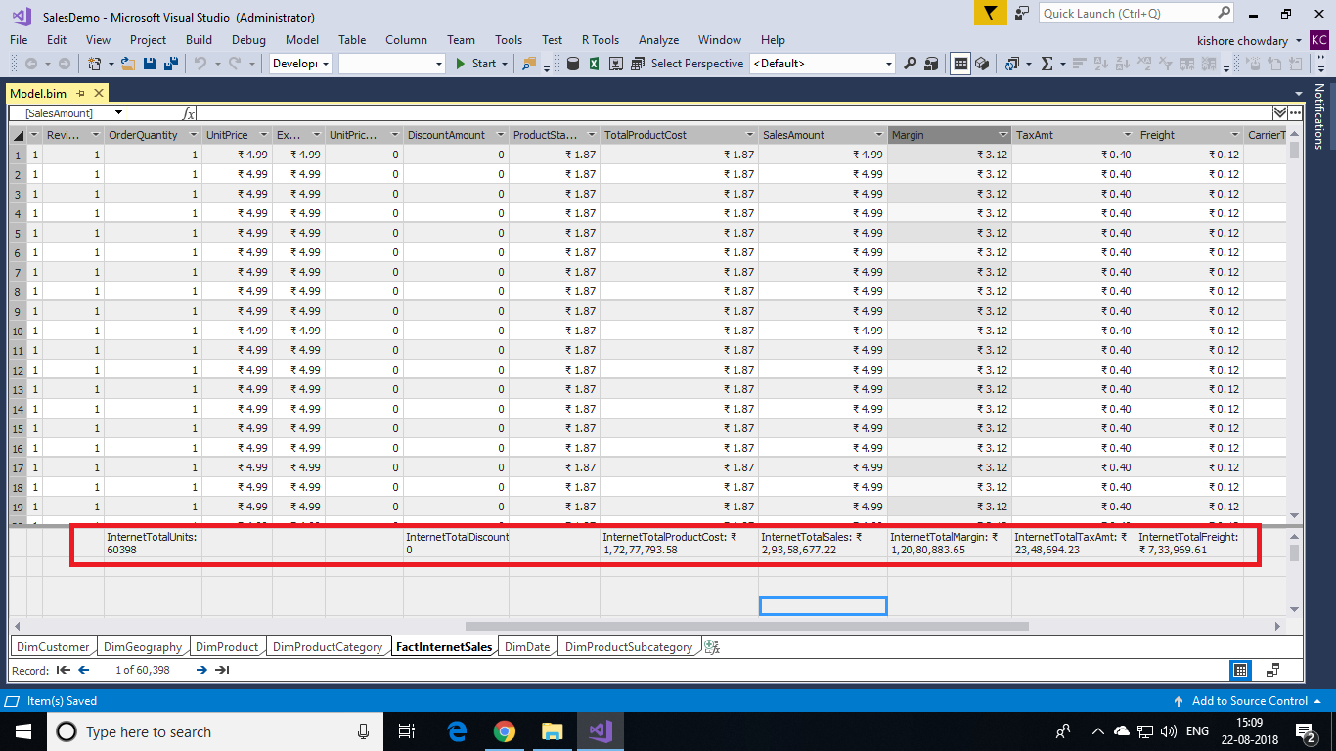

1. By clicking an empty cell in the measure grid, and by using the formula bar, create, the following custom measures in order:

**InternetPreviousQuarterMargin:**

InternetPreviousQuarterMargin:=CALCULATE([InternetTotalMargin],PREVIOUSQUARTER('DimDate'[Date]))

**InternetCurrentQuarterMargin**

InternetCurrentQuarterMargin:=TOTALQTD([InternetTotalMargin],'DimDate'[Date])

**InternetPreviousQuarterMarginProportionToQTD**

InternetPreviousQuarterMarginProportionToQTD:=[InternetPreviousQuarterMargin]*([DaysCurrentQuarterToDate]/[DaysInCurrentQuarter])

**InternetPreviousQuarterSales**

InternetPreviousQuarterSales:=CALCULATE([InternetTotalSales],PREVIOUSQUARTER('DimDate'[Date]))

**InternetCurrentQuarterSales**

InternetCurrentQuarterSales:=TOTALQTD([InternetTotalSales],'DimDate'[Date])

**InternetPreviousQuarterSalesProportionToQTD**

InternetPreviousQuarterSalesProportionToQTD:=[InternetPreviousQuarterSales]*([DaysCurr

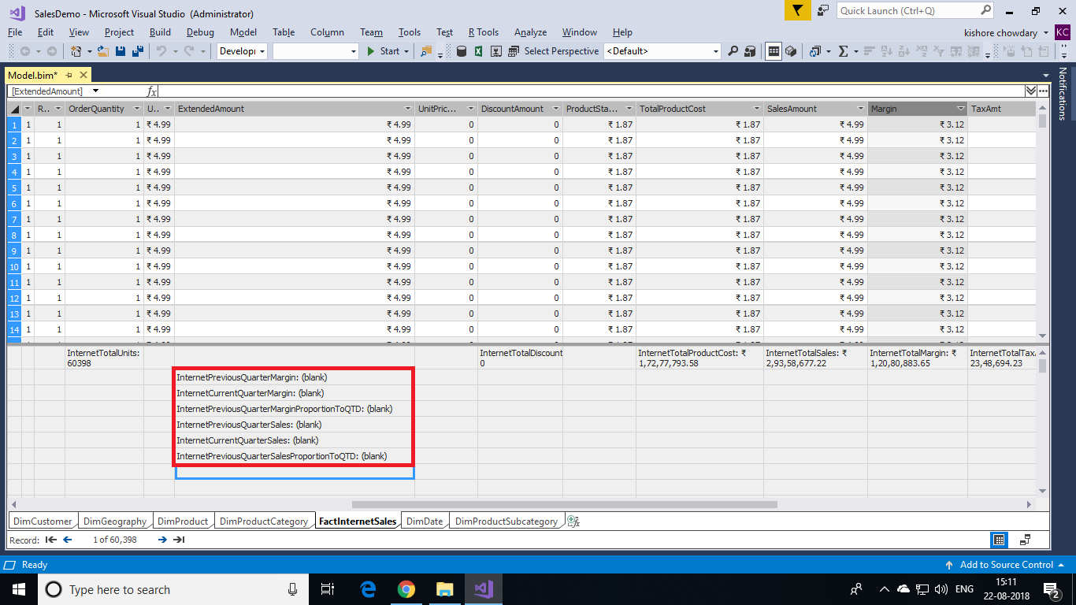

Measures created for the FactInternetSales table can be used to analyze critical financial data such as sales, costs, and profit margin for items defined by the user selected filter.